PROJECT DEVELOPMENT PHASE 5
Script Development
Script-Controlled ACL – Restrict Record Access Based on Field Value
Project Details | Values
Date | 30 September 2026
Team ID | SWTID-2026-8983
Project Name | Script-Controlled ACL – Restrict Record Access Based on Field Value
Phase | Phase 5 – Script Development
Maximum Marks | 5 Marks

Team Role | Team Member
Team Leader | NITHYA SREE S
Team Member | RAMASRI D
Team Member | PRATHISHA S
Team Member | MEGALA M
Team Member | MANJARI T

1. Objective
Implement the script-controlled decision that checks the record's field value and the current user's approved access.

2. Phase Workflow
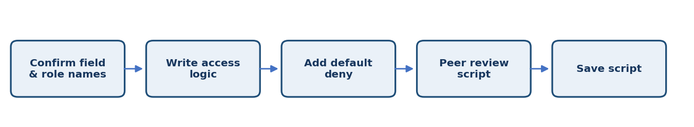

3. Activities / Scope
- Write a concise ACL script using the actual field and role names.
- Implement explicit allow rules for approved field values.
- Return deny by default for blank or unknown values.
- Handle any approved ownership exception carefully.
- Review the script for readability, least privilege, and maintainability.

4. Sprint Backlog & Estimation
Sprint | Story ID | Requirement | User Story / Task | Story Points | Priority | Team Members
Sprint 5 | US-501 | Write field-value logic | Check the record field and approved access role. | 3 | High | Project Team
Sprint 5 | US-502 | Add safe default | Deny blank or unexpected field values. | 2 | Medium | Project Team
Sprint 5 | US-503 | Review script | Check naming, logic, and security assumptions. | 2 | Medium | Project Team

Total Estimated Story Points: 7

5. Testing / Review Template
Test Case ID | Scenario / Steps | Expected Result | Actual Result | Status
TC-01 | Run controlled script checks for every approved field value and user role; confirm unexpected values do not grant access. | Expected behavior matches approved requirement. | ________________ | Pass / Fail
TC-02 | Record observations, issues, and evidence for this phase. | No unresolved blocker before phase sign-off. | ________________ | Pass / Fail
TC-03 | Review phase deliverables with the responsible team member. | Deliverables reviewed and approved. | ________________ | Pass / Fail

6. Deliverables
- ACL script
- Script review notes
- Updated configuration record

7. Team Review & Sign-off
Review Item | Details
Prepared by | Megala M / Project Team
Reviewed by | ____________________________
Approval / Date | ____________________________
Remarks | ________________________________________________

